**1. Project Overview**

**1.1 Purpose of the Project**

The purpose of the eBallot project is to develop a secure, reliable, and efficient online voting system. It aims to reduce manual errors, save time, and ensure transparency in different types of elections.

**1.2 Project Description**

eBallot is a secure online voting system that can be used for national, local, or any organizational election. The system supports area-based voting (such as district or constituency-wise voting) and ensures one vote per voter.

**2. System Description**

This project is a web application that can be implemented in any voting booth or for a specific area, such as the 14 constituencies of Dhaka district. The system allows separate vote collection for each constituency. All votes are stored securely and can later be centrally counted and monitored to produce accurate election results.

**3. User Interaction**

This section shows how users and the admin interact with the system.

**Screenshot 1: User Registration**



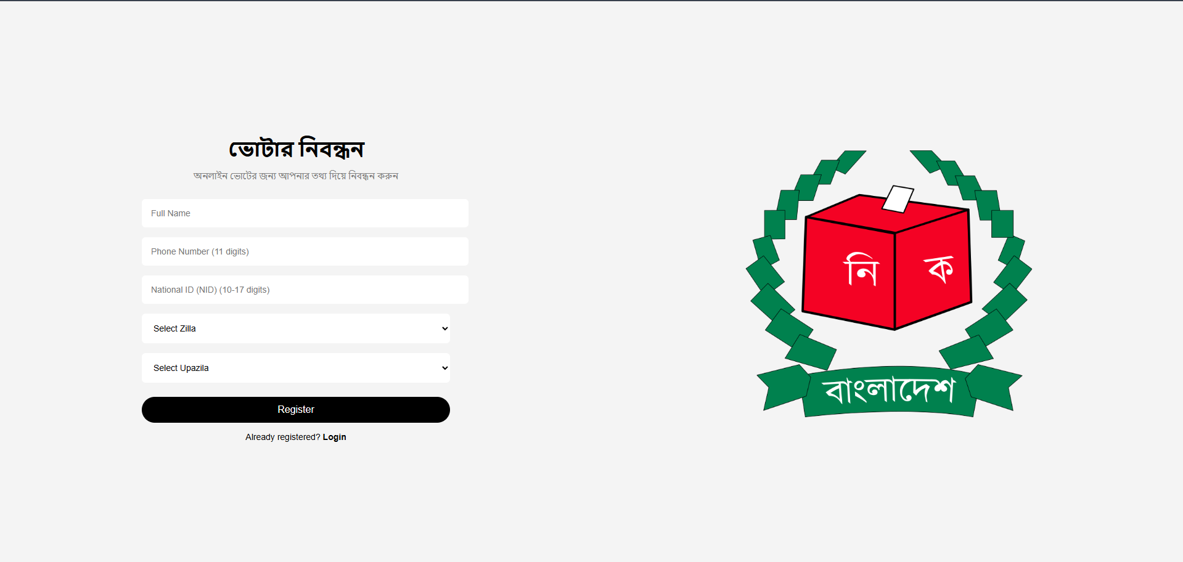**Description:**  
Users register by providing required details and automatically receive a unique Voter ID.

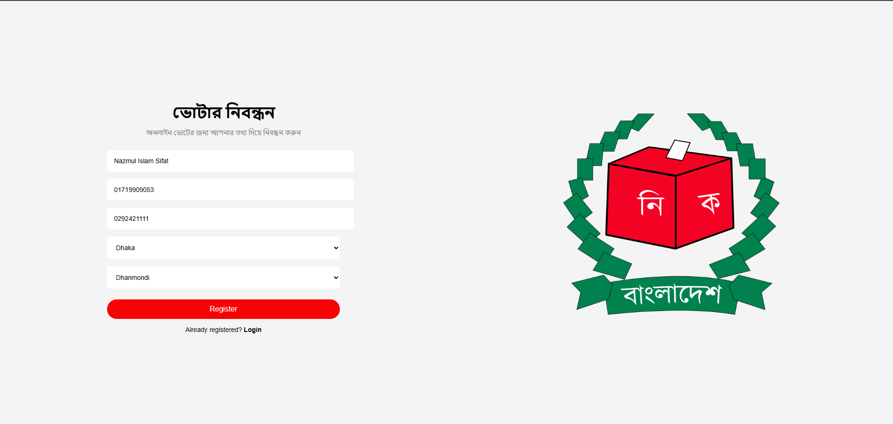

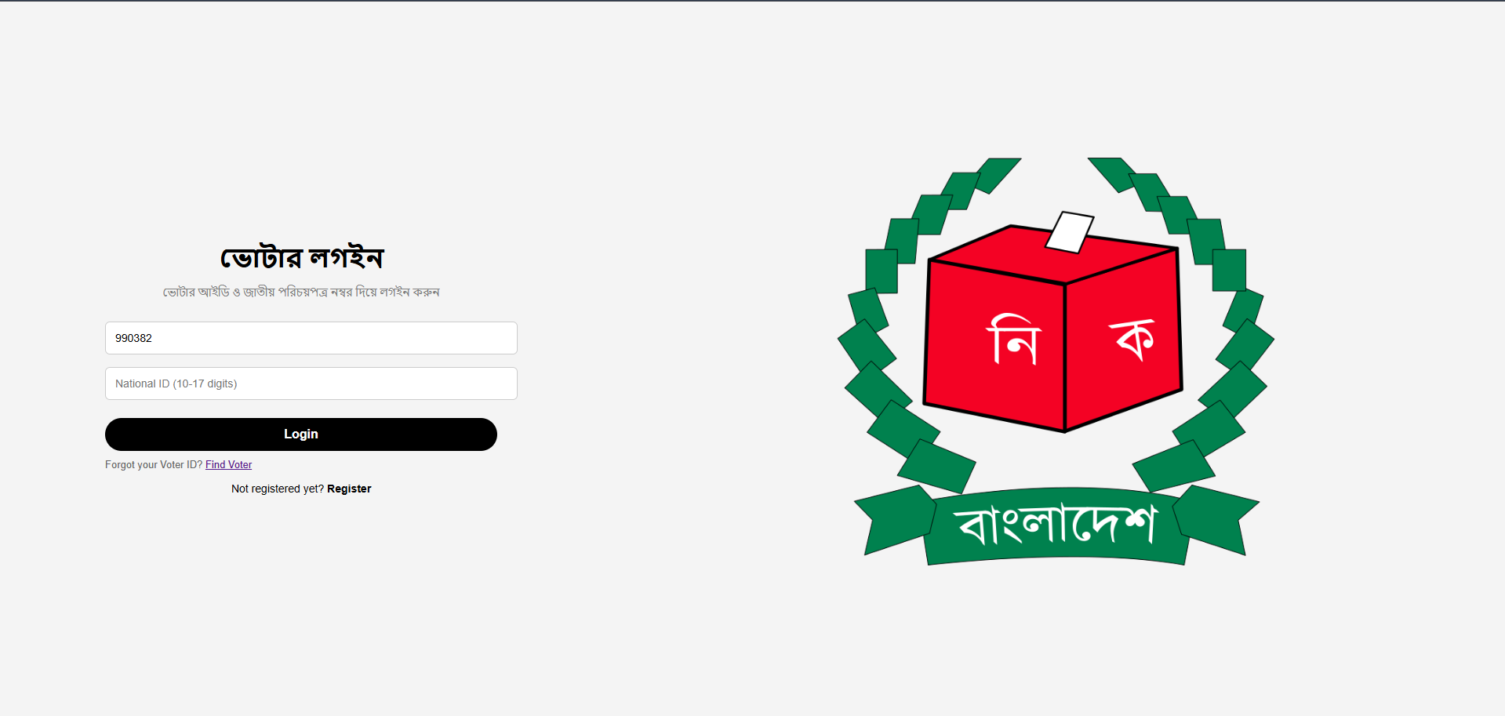

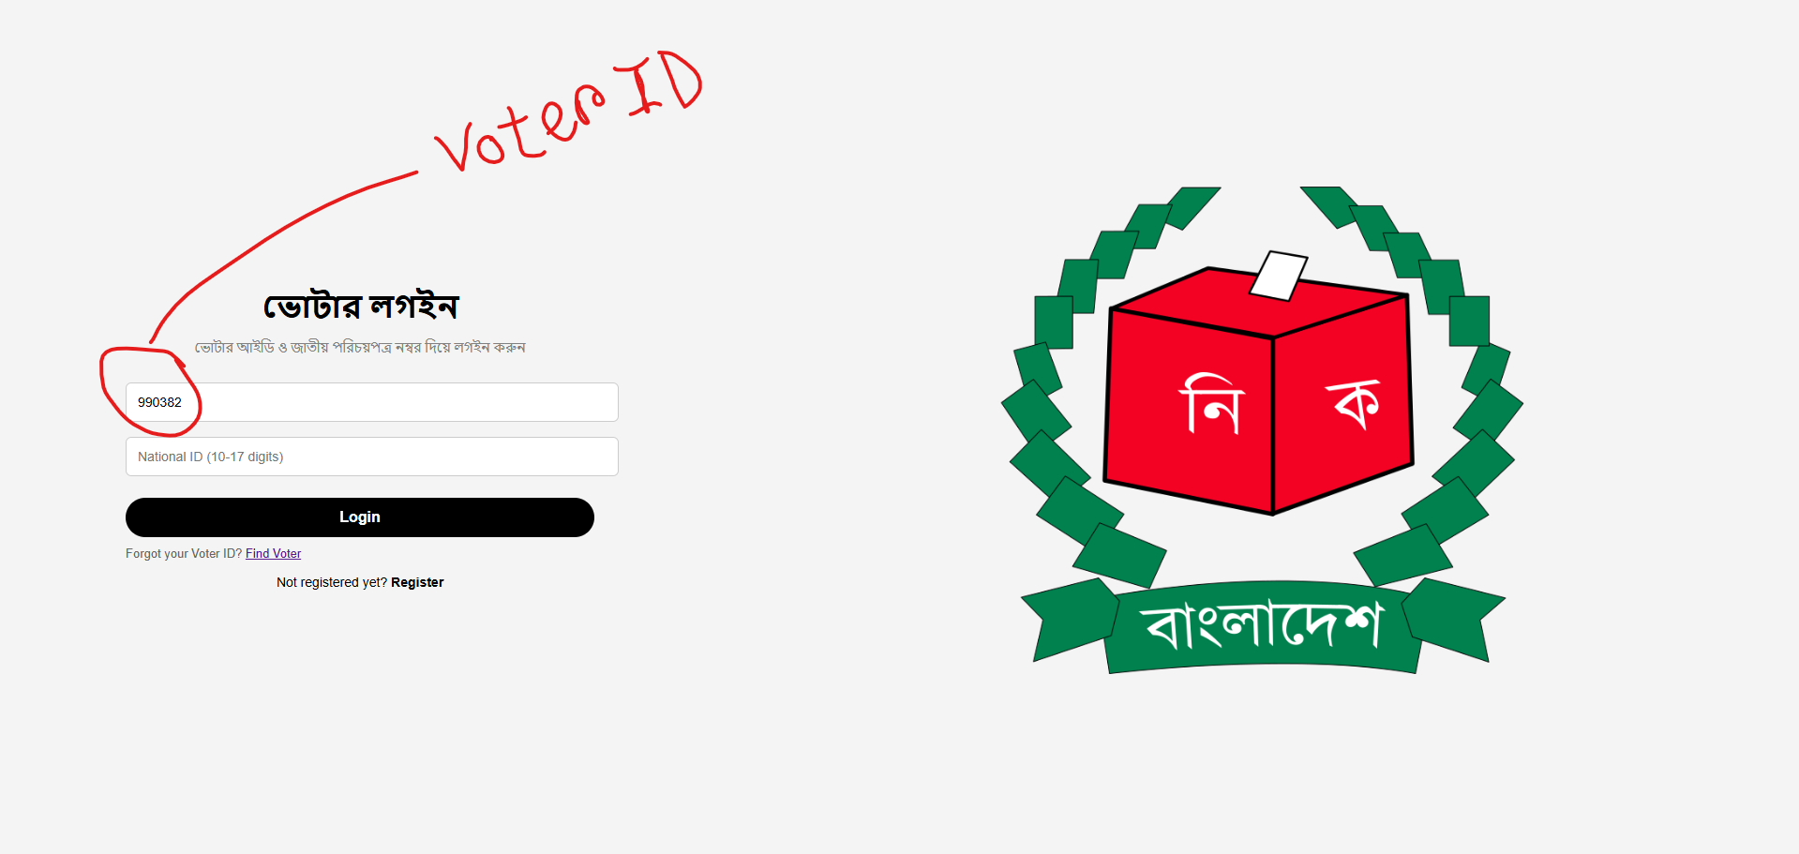

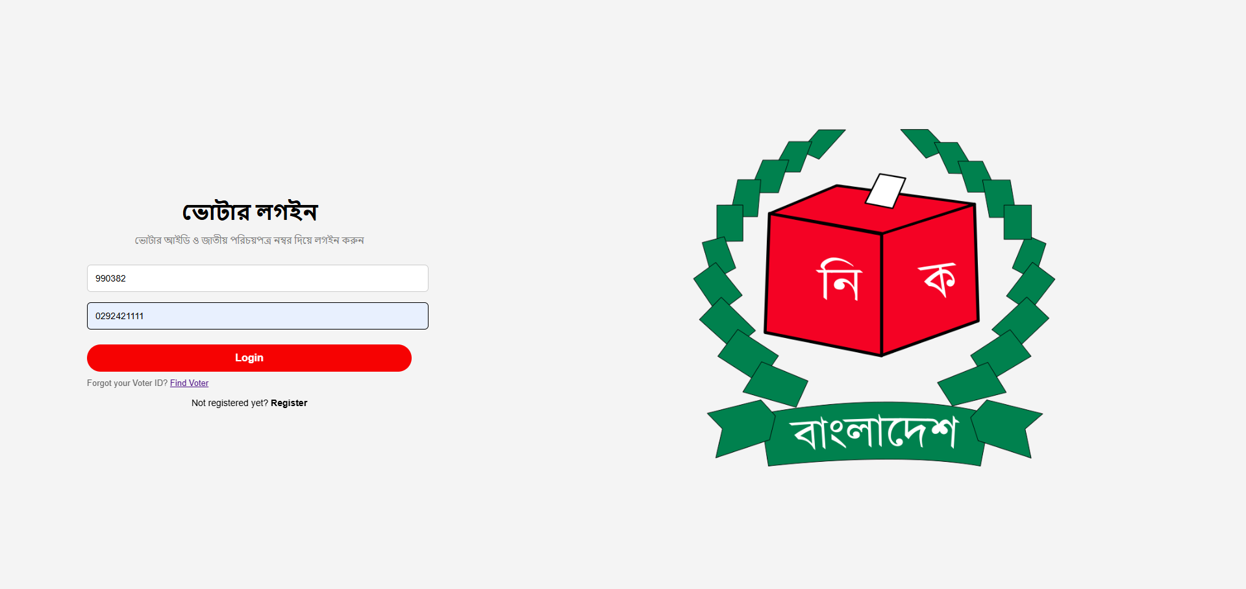

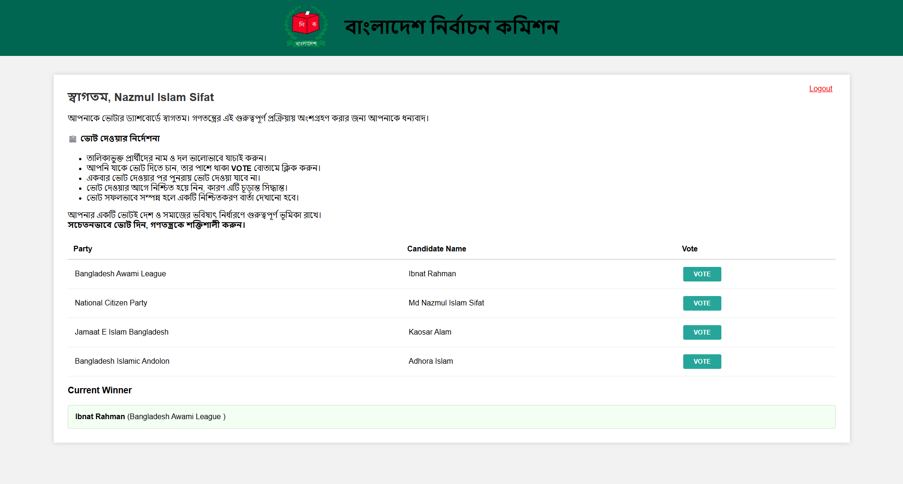

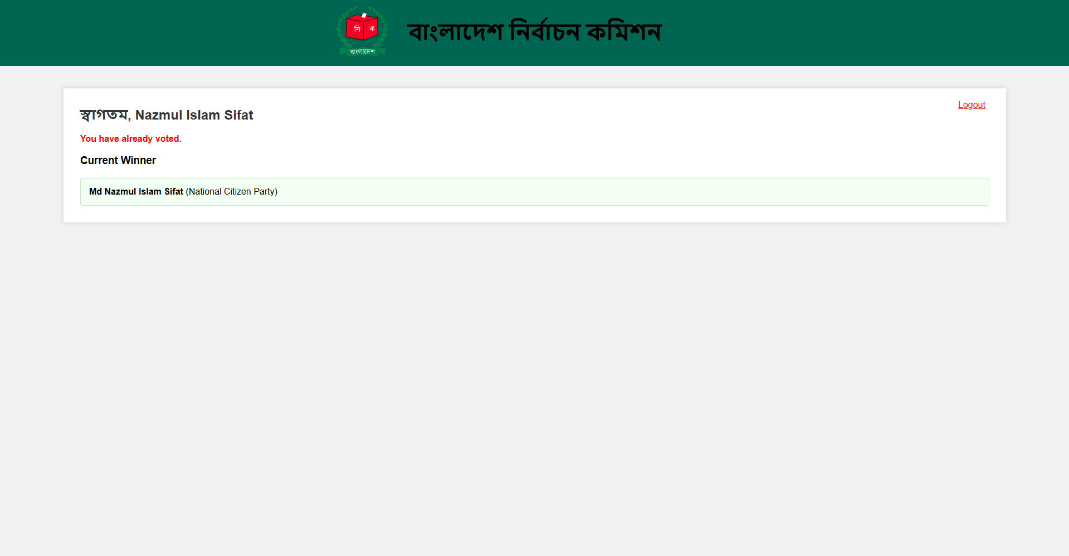

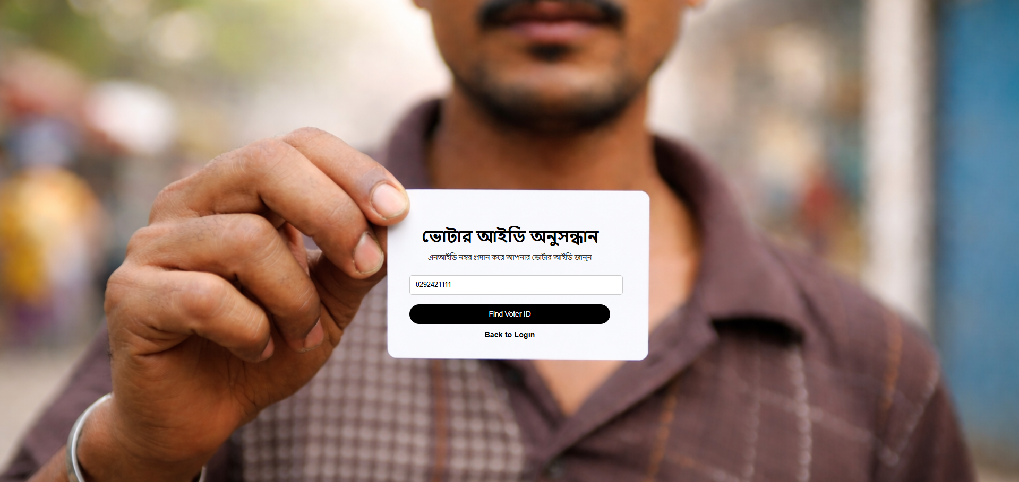

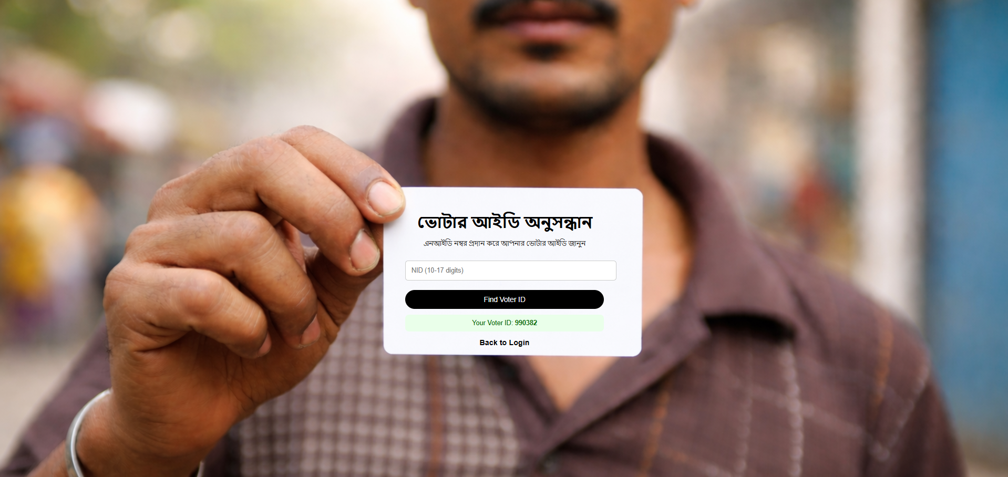



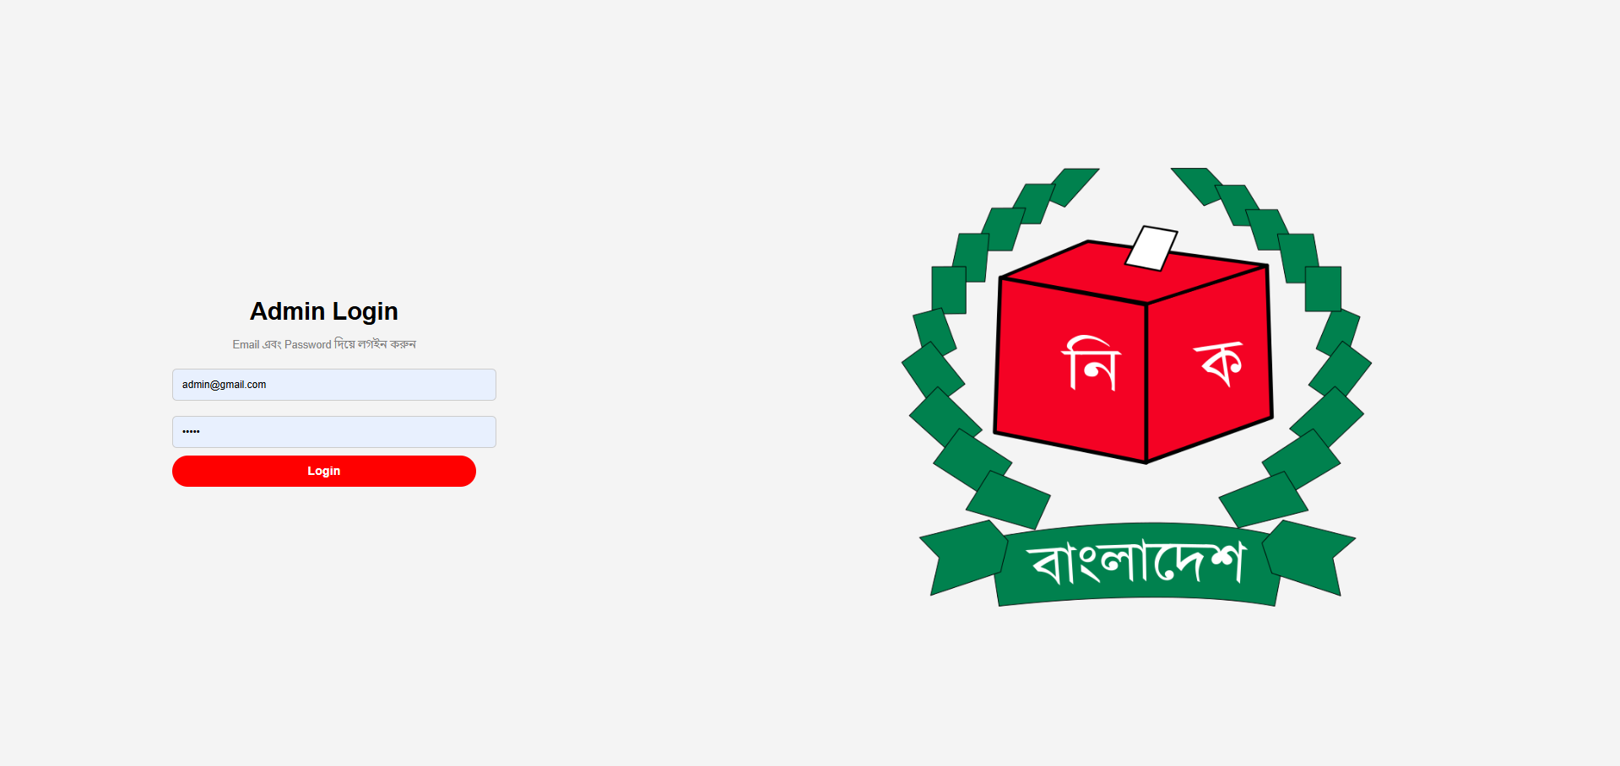

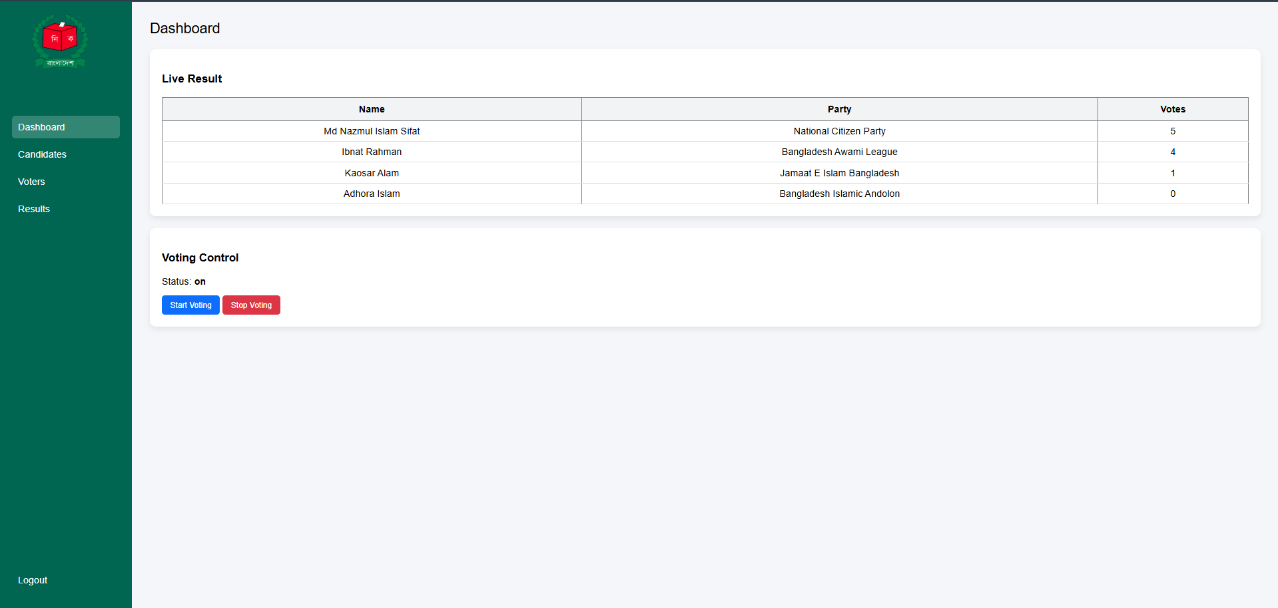

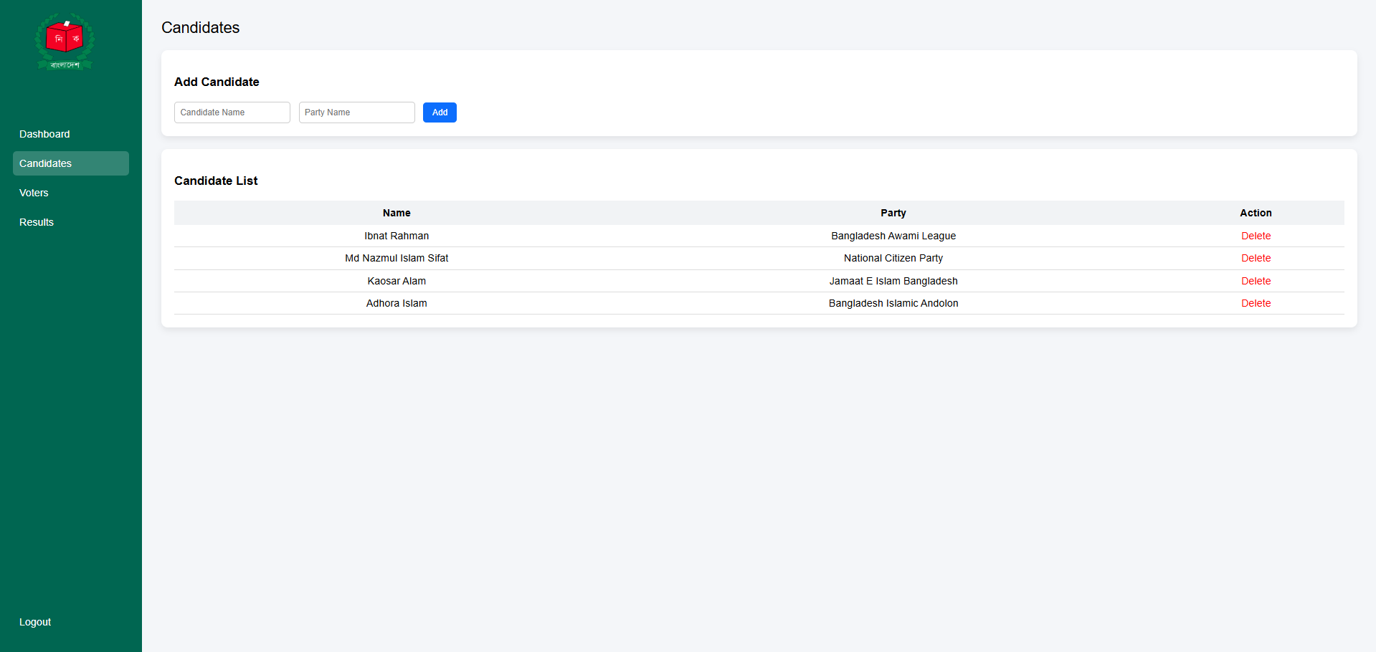

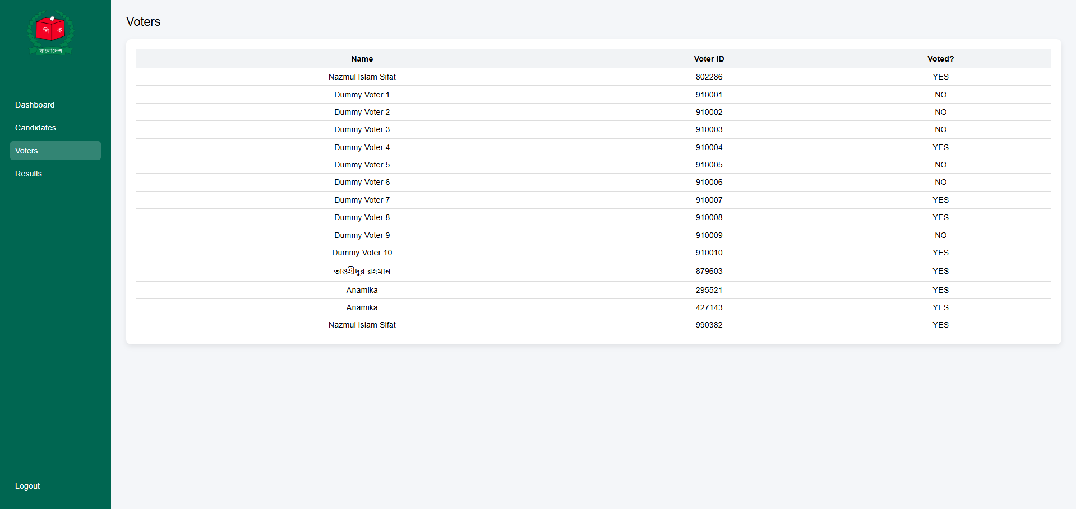

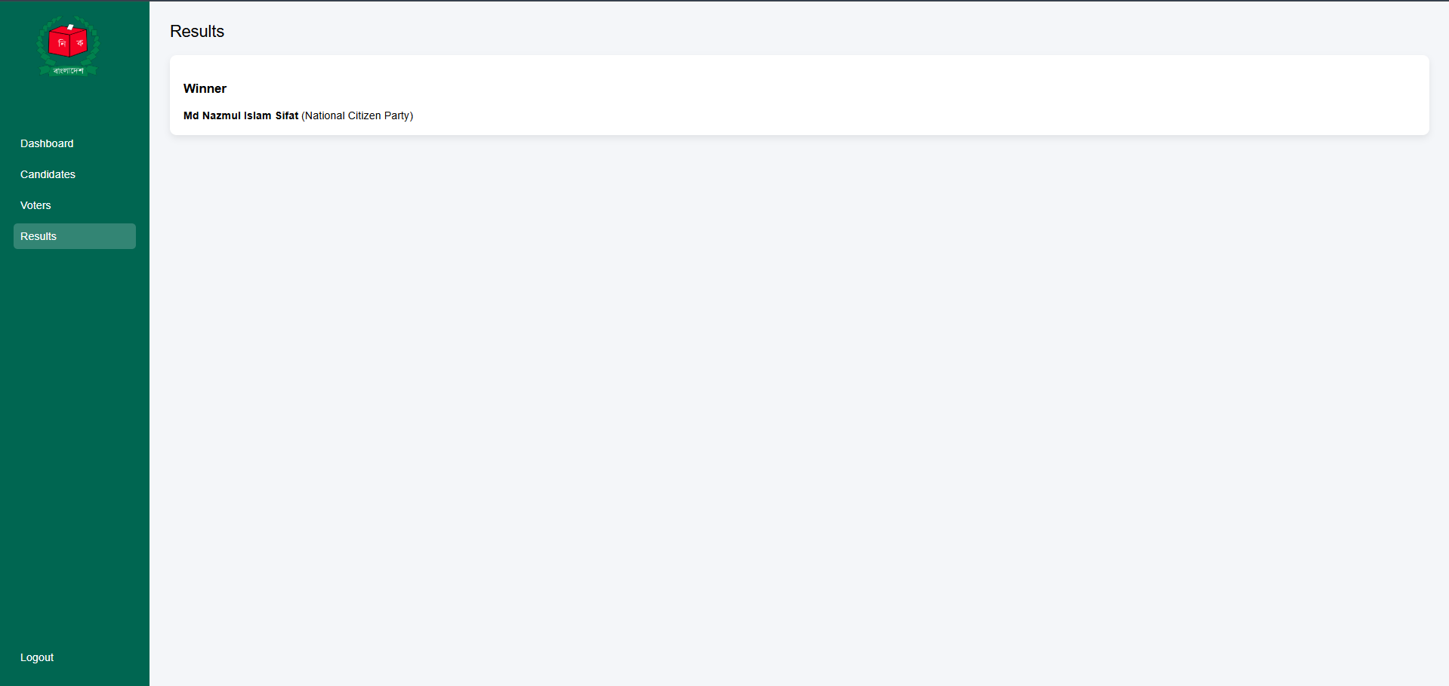

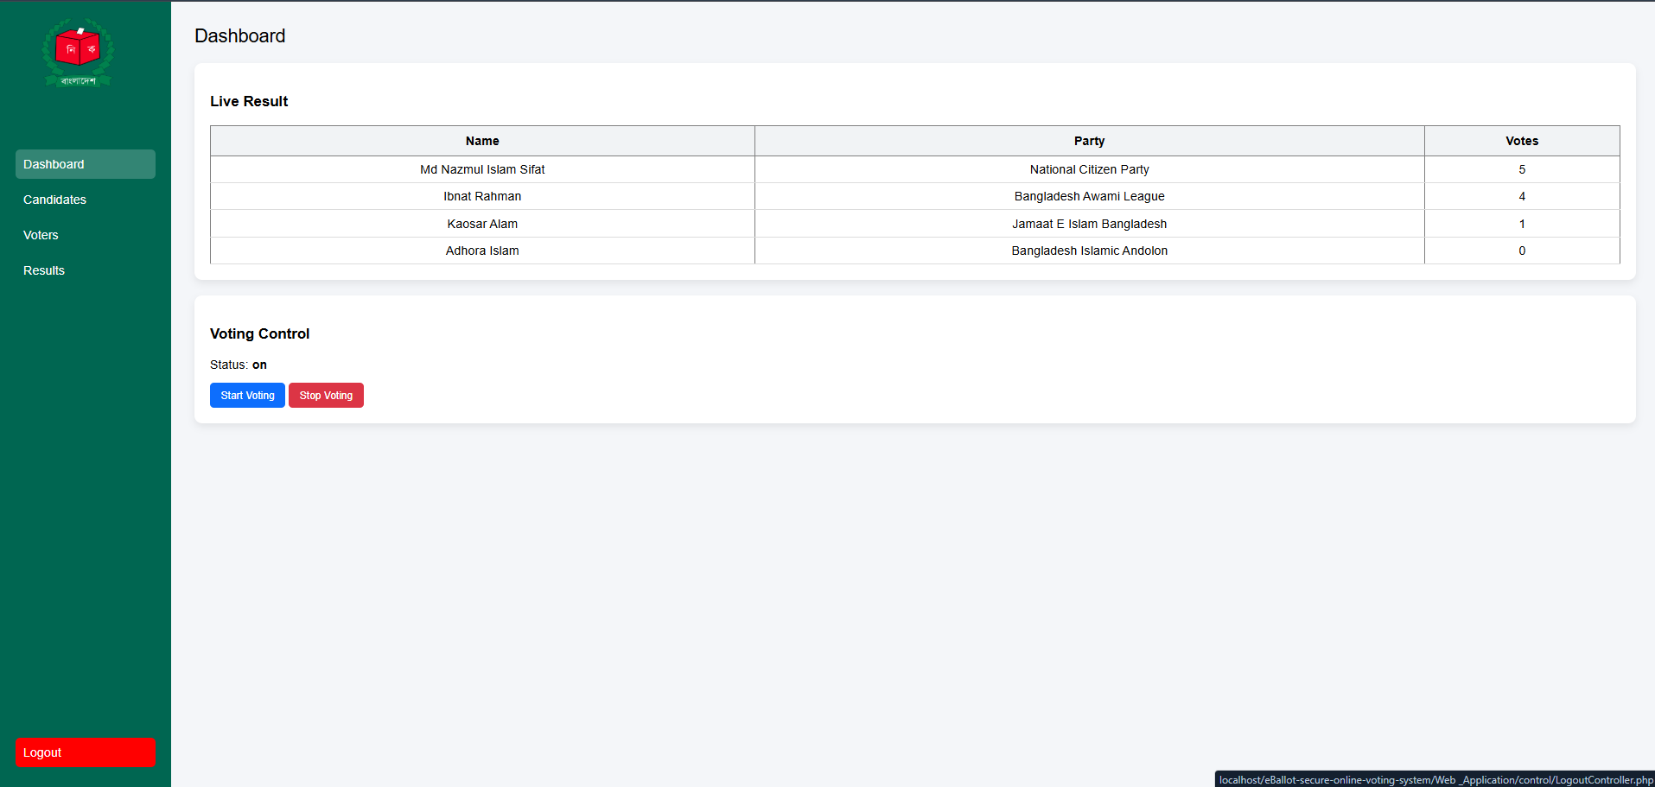

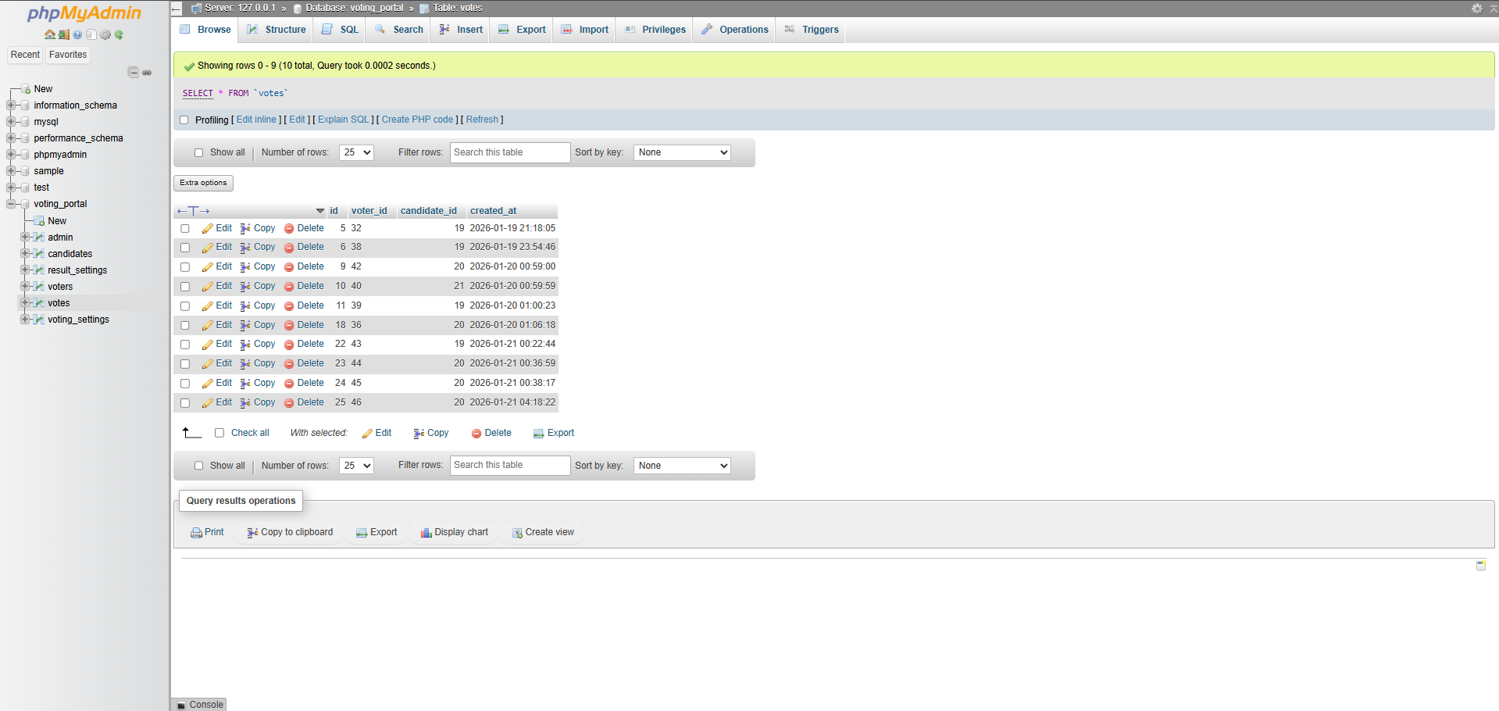

**Screenshot 2: Voting Process**

📸 *Insert Screenshot Here*

**Description:**  
Voters log in using their Voter ID and cast a vote for their selected candidate.

**Screenshot 3: Admin Dashboard**

📸 *Insert Screenshot Here*

**Description:**  
The admin can add or remove candidates, monitor live vote counts, manage voters, and control the election.

**4. Conclusion**

The eBallot project is a modern and efficient voting solution that can be used for large-scale elections. Through this project, I gained practical experience in secure system design, user authentication, admin control, and real-time data monitoring.

**5. Declaration**

I hereby declare that this project is my own work and has been completed according to the given instructions.

**Student Signature:** ________________________  
**Date:** ____________________